Name - AFELUMO TEMIDAYO TOM

Topic -Conceptual Model Checkpoint

Date - 08/09/2023

**INSTRUCTIONS** -

You are given a 3 entities as a database tables:

"products": a table that stores information about the products sold by a company. The table has the following structure:

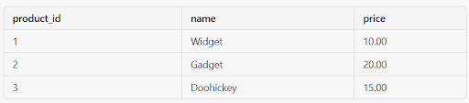

"customers": a table that stores information about the customers of the company. The table has the following structure:

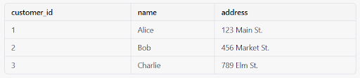

"orders": a table that stores information about the orders placed by the customers. The table has the following structure

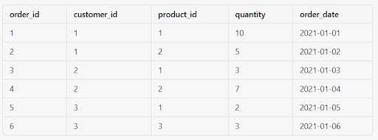

**Instructions-** Given the above mentioned entities(products, customers, orders), create the corresponding entity-relationship(conceptual) model.

**ANSWERS**-

| PRODUCT |
| --- |
| Product_id  Name  Price |

product(**product_id,**name, price)

| CUSTOMER |
| --- |
| Customer _id  Name  Address |

Customer( **Customer_id**, name, address)

| ORDER |
| --- |
| Order_id  Customer_id  Product_id  Quantity  Order_date |

Order (**Order_id,** order_id, customer_id, product_id, quality, order_date)